**Descriptives**

|  |  |  |  |  |  |
| --- | --- | --- | --- | --- | --- |
| **Descriptive Statistics** | | | | | |
|  | N | Minimum | Maximum | Mean | Std. Deviation |
| DER | 32 | .89 | 1.93 | 1.2978 | .27356 |
| ROA | 32 | .01 | .11 | .0594 | .03079 |
| Harga_Saham | 32 | 531.21 | 2945.89 | 1556.4594 | 718.58581 |
| Valid N (listwise) | 32 |  |  |  |  |

**Pengaruh DER Terhadap Harga Saham**

|  |  |  |  |  |
| --- | --- | --- | --- | --- |
| **Model Summary** | | | | |
| Model | R | R Square | Adjusted R Square | Std. Error of the Estimate |
| 1 | .790a | .623 | .611 | .29424 |
| a. Predictors: (Constant), DER | | | | |

|  |  |  |  |  |  |  |
| --- | --- | --- | --- | --- | --- | --- |
| **ANOVAa** | | | | | | |
| Model | | Sum of Squares | df | Mean Square | F | Sig. |
| 1 | Regression | 4.298 | 1 | 4.298 | 49.643 | .000b |
| Residual | 2.597 | 30 | .087 |  |  |
| Total | 6.895 | 31 |  |  |  |
| a. Dependent Variable: HS1 | | | | | | |
| b. Predictors: (Constant), DER | | | | | | |

|  |  |  |  |  |  |  |
| --- | --- | --- | --- | --- | --- | --- |
| **Coefficientsa** | | | | | | |
| Model | | Unstandardized Coefficients | | Standardized Coefficients | t | Sig. |
| B | Std. Error | Beta |
| 1 | (Constant) | 9.011 | .256 |  | 35.193 | .000 |
| DER | -1.361 | .193 | -.790 | -7.046 | .000 |
| a. Dependent Variable: HS1 | | | | | | |

**Pengaruh ROA Terhadap Harga Saham**

|  |  |  |  |  |
| --- | --- | --- | --- | --- |
| **Model Summary** | | | | |
| Model | R | R Square | Adjusted R Square | Std. Error of the Estimate |
| 1 | .166a | .027 | -.005 | .47278 |
| a. Predictors: (Constant), ROA | | | | |

|  |  |  |  |  |  |  |
| --- | --- | --- | --- | --- | --- | --- |
| **ANOVAa** | | | | | | |
| Model | | Sum of Squares | df | Mean Square | F | Sig. |
| 1 | Regression | .190 | 1 | .190 | .848 | .364b |
| Residual | 6.706 | 30 | .224 |  |  |
| Total | 6.895 | 31 |  |  |  |
| a. Dependent Variable: HS1 | | | | | | |
| b. Predictors: (Constant), ROA | | | | | | |

|  |  |  |  |  |  |  |
| --- | --- | --- | --- | --- | --- | --- |
| **Coefficientsa** | | | | | | |
| Model | | Unstandardized Coefficients | | Standardized Coefficients | t | Sig. |
| B | Std. Error | Beta |
| 1 | (Constant) | 7.094 | .184 |  | 38.586 | .000 |
| ROA | 2.540 | 2.758 | .166 | .921 | .364 |
| a. Dependent Variable: HS1 | | | | | | |

**Pengaruh DER dan ROA Terhadap Harga Saham**

|  |  |  |  |  |  |
| --- | --- | --- | --- | --- | --- |
| **Model Summaryb** | | | | | |
| Model | R | R Square | Adjusted R Square | Std. Error of the Estimate | Durbin-Watson |
| 1 | .793a | .629 | .603 | .29717 | .827 |
| a. Predictors: (Constant), ROA, DER | | | | | |
| b. Dependent Variable: HS1 | | | | | |

|  |  |  |  |  |  |  |
| --- | --- | --- | --- | --- | --- | --- |
| **ANOVAa** | | | | | | |
| Model | | Sum of Squares | df | Mean Square | F | Sig. |
| 1 | Regression | 4.334 | 2 | 2.167 | 24.539 | .000b |
| Residual | 2.561 | 29 | .088 |  |  |
| Total | 6.895 | 31 |  |  |  |
| a. Dependent Variable: HS1 | | | | | | |
| b. Predictors: (Constant), ROA, DER | | | | | | |

|  |  |  |  |  |  |  |  |  |
| --- | --- | --- | --- | --- | --- | --- | --- | --- |
| **Coefficientsa** | | | | | | | | |
| Model | | Unstandardized Coefficients | | Standardized Coefficients | t | Sig. | Collinearity Statistics | |
| B | Std. Error | Beta | Tolerance | VIF |
| 1 | (Constant) | 9.131 | .319 |  | 28.623 | .000 |  |  |
| DER | -1.400 | .204 | -.812 | -6.851 | .000 | .911 | 1.097 |
| ROA | -1.164 | 1.816 | -.076 | -.641 | .527 | .911 | 1.097 |
| a. Dependent Variable: HS1 | | | | | | | | |

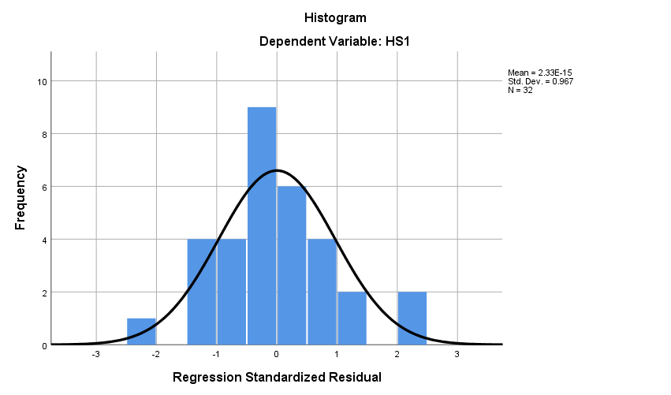

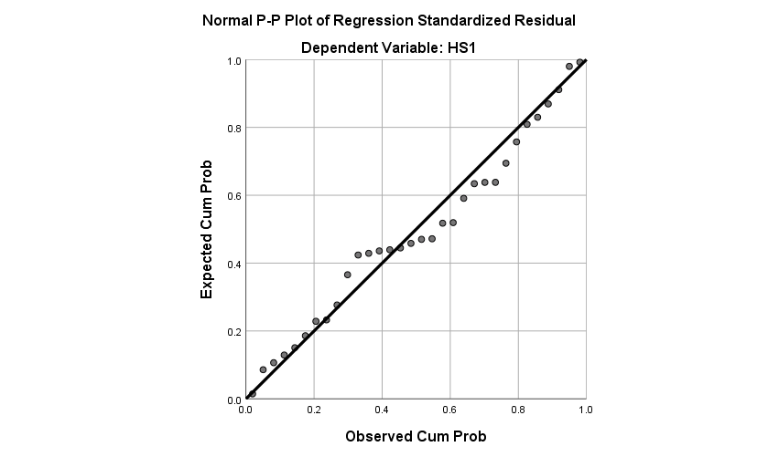

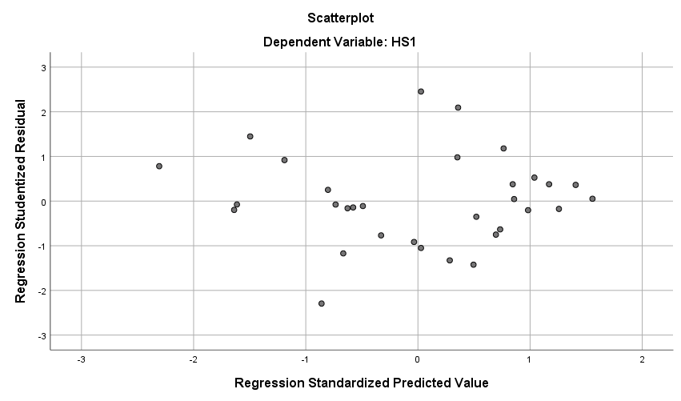

**NPar Tests**

|  |  |  |
| --- | --- | --- |
| **One-Sample Kolmogorov-Smirnov Test** | | |
|  | | Unstandardized Residual |
| N | | 32 |
| Normal Parametersa,b | Mean | .0000000 |
| Std. Deviation | .28742886 |
| Most Extreme Differences | Absolute | .109 |
| Positive | .107 |
| Negative | -.109 |
| Test Statistic | | .109 |
| Asymp. Sig. (2-tailed) | | .200c,d |
| a. Test distribution is Normal. | | |
| b. Calculated from data. | | |
| c. Lilliefors Significance Correction. | | |
| d. This is a lower bound of the true significance. | | |